Project Design Phase-II

Technology Stack (Architecture & Stack)

Date | 12th February 2026
Team ID | LTVIP2026TMIDS66183
Project Name | Civil Engineering Insight Studio
Maximum Marks | 4 Marks

Technical Architecture:
The Deliverable shall include the architectural diagram as below and the information as follows:
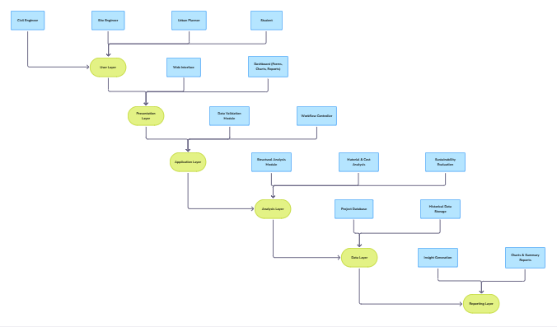

Table-1 : Components & Technologies:

S.No | Component | Description | Technology
1. | User Layer | End users such as civil engineers, site engineers, planners, and students interact with the system. | Web Browser
2. | Presentation Layer | Provides a user-friendly interface to enter project details and view analytical results. | HTML  CSS  JavaScript
3. | Application Layer | Validates user inputs and manages the flow of data between modules. | Python  Streamlit(Web Framework)
4. | Analysis Layer | Core component where structural safety, cost efficiency, and sustainability are evaluated. | Python  Engineering formulas & logic
5. | Data Layer | Stores project data, analysis results, and historical records for future reference. | CSV files  Local storage / File system
6. | Report Layer | Generates final insights, graphs, and reports for decision-making. | Python  Matplotlib / Charts  HTML reports

Table-2: Application Characteristics:

S.No | Characteristics | Description | Technology
1. | Open-Source Frameworks | Uses open-source tools to reduce cost and improve flexibility and maintainability. | Python’s Streamlit
2. | Scalability | The system can support multiple civil engineering project types such as buildings, roads, and bridges. | Modular architecture
3. | Performance | Provides fast analysis and report generation for engineering insights. | Efficient Python logic
4. | Availability | Accessible whenever required for project analysis and planning. | Local / Web deployment
5. | Usability | Easy-to-use interface suitable for engineers and students. | HTML, CSS
6. | Security | Protects project data from unauthorized access. | input validation, access control

